**Global Maths & English Policy**

**Introduction**

Global is committed to supporting employability, excellence, enterprise and progression for all. It is recognised that the development of maths and English skills enables individuals to achieve their full potential and function independently in all aspects of their personal and professional life.

GLOBAL provide opportunities for all learners to improve their confidence and competence in maths and English; essential skills for both progression to and within employment or onto further study.

**Aim**

To ensure all learners have consistent, regular opportunities to improve their confidence and competencies in maths and English, gain further qualifications and apply these skills to all aspects of their personal and professional lives.

**Leadership of Maths & English**

GLOBAL take a whole organisation approach to the strategic delivery of maths and English which is led by Directors. All staff have the responsibility for the positive promotion of the organisation’s aspirational vision and the delivery of maths and English through standalone and embedded learning and development activities. Achievements are monitored by Directors.

Maths & English Provision

· All learners aged 16-18 commencing on a vocational study programme without a Grade 4/C or above in GCSE English and/or maths will continue to study these subjects to achieve a Functional Skills qualification or GCSE by the time they complete their training with Global.

· All learners aged 16-18 who commence a vocational study programme having achieved GCSE Grade 4/C or above in English and maths can further develop their skills to improve their opportunities for employment and further study.

· Learners on an apprenticeship programme without a GCSE Grade 4/C in English and maths will undertake English & maths at the level appropriate to them which is at or above the level required by their Apprenticeship Standard/Framework.

· All Apprentices will study towards a Level 2 or GCSE English/Maths qualification even if they have achieved the minimum requirement of the Standard or Framework.

GLOBAL will:

· provide high quality, impartial advice and guidance together with initial and diagnostic assessment to ensure each learner is placed on the right programme and has an appropriate qualification pathway for maths & English;

· ensure Training Consultants take a consistent approach to the delivery of maths 1 and English;

· provide a team of specialist maths and English specialists to provided specialist support for staff and learners;

· improve standards in teaching, learning and assessment of maths and English across all programmes ensuring they are embedded in all learning;

· raise success rates in maths and English;

· provide learners with the opportunity for on programme progression to the next level of attainment or qualification;

· ensure that the delivery of maths and English is flexible in terms of location, time, method and vocational context to meet the needs of learners and where appropriate employers.

Delivery of Maths & English Maths and English are delivered through a combination of standalone and embedded learning and development activities. The delivery of maths and English supports and underpins all vocational learning.

Every vocational session should develop maths and English skills in the context of the subject to support high quality teaching, learning and assessment. All training staff are required to:

· identify the development opportunities for English and maths in schemes of work and session plans;

· provide consistent marking and feedback of learners’ written work for spelling, punctuation and grammar;

· extend the opportunities for the use of data in coursework eg using graphs and charts in presentations;

· encourage the use of verbal and written language in a wide range of contexts including presentations, written reports, role plays, professional discussion and the working environment;

· ensure close working relationships between vocational staff and specialist maths and English colleagues. Roles and Responsibilities Directors will:

· oversee the implementation of HTPs maths and English policy to ensure contractual requirements are met;

· support Senior Managers to implement the maths and English policy;

· implement and deliver the maths and English policy;

· support and deliver staff development for trainers on the embedding of maths and English in main learning;

· support the improvement of teaching, learning and assessment in maths and English through, for example, specific workshops and sharing of good practice as identified through observations of learning;

· be accountable for the maths and English success rates for learners in their area of responsibility.

Trainers will:

· ensure that every learner has taken and there is a record of their initial and diagnostic assessment; · check and confirm that every learner’s prior achievement in maths and English; 2

· ensure vocational timetabling allows all students to access appropriate maths and English support sessions;

· set clear and relevant learning objects/targets for each learner in maths & English throughout their programme of learning;

· plan and deliver maths and English support to meet learner needs;

· promote and encourage accurate and consistent use of maths and English skills;

· seek ideas, consult with colleagues including maths and English specialists to introduce innovative ways to embed maths and English in planned learning;

· check and record the progress of every learner in maths and English in relation to their individual targets;

· regularly confirm each learner’s maths and English aims are appropriate;

· ensure timely entry to external examinations to meet programme requirements;

· ensure maths and English results are collected and recorded for each learner;

· maintain regular contact with maths and English specialists;

Staffing and CPD

All managers, training and support staff receive training to enable them to successfully undertake their role in relation to Global’s Whole Organisational Approach to maths and English. Staff maths and English skills, capabilities and knowledge are reviewed at Initial Staff Induction and in subsequent 1 to 1 and appraisal meetings. CPD programmes are agreed to address identified development needs. The implementation of skills and knowledge gained by staff from CPD is tracked and the impact evaluated. All Training staff and Learning Support Assistants are trained to recognise naturally occurring opportunities to develop learners’ maths and English skills.

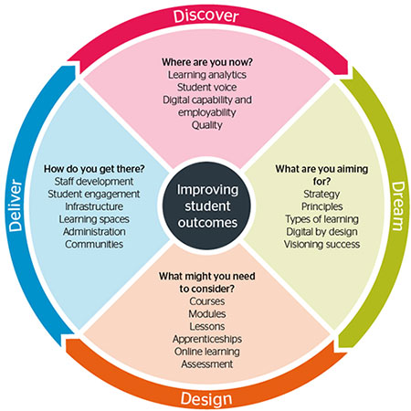   
  
  
  
  
  
  
  
  
  
  
  
  
  
  
  
  
 3